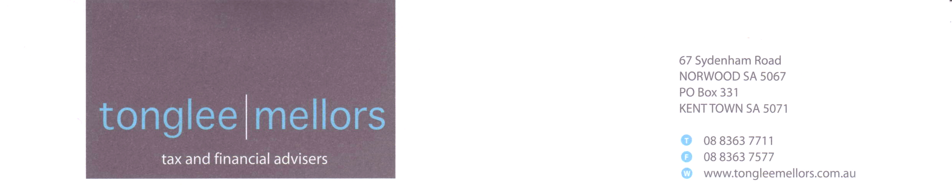

Financial Services Guide
(FSG)

Purpose of this guide

This guide is designed to assist you in deciding whether to use our financial services and contains important information on:

- Who we are and what we do
- What services and types of products we are authorised to offer to you
- How we and our representatives (Advisers) are paid
- Any potential conflict of interest
- Our dispute resolution procedures

Who we are and what we do

We are an experienced, boutique business providing financial advice for those looking to plan astutely to achieve financial independence. We take pride in delivering proactive advice that is tailored to our clients specific situation and are committed to providing ongoing service that is personalised and prompt.

We place great importance on taking the time to communicate with, educate and guide our clients. This leads to sensible, informed, decision-making that achieves satisfactory outcomes which have formed the basis of rewarding relationships we have enjoyed with our clients over many years.

Much of our advice focuses on using the superannuation system to tax effectively accumulate assets and invest wisely to provide income in retirement. Typically our clients want flexibility and control over their financial situation and our advice enables them to achieve that.

We are 100% privately owned and hold our own Australian Financial Services License.

By not being aligned to or controlled by financial institutions or product providers we avoid external influences and potential conflicts of interest. In short, this means the strategies we utilise and investments we recommend are unbiased and in our clients’ best interest. To this end, we seek to invest in products that do not pay commission.

We extend an invitation to potential new clients by offering a free initial appointment to discuss your situation and determine whether we can be of service.

The services and types of products we are authorised to offer you

We are authorised to carry on a financial services business to provide financial product advice on and deal (transact) in the following classes of financial products:

- Basic deposit products
- Life insurance (investment & risk) products
- Managed investments schemes; including investor directed portfolio services (IDPS)
- Retirement savings accounts
- Securities
- Standard margin lending facilities
- Superannuation

Responsibility for advice given

Tonglee Financial Services Pty Ltd authorises its representatives (Advisers) to give advice and is responsible for the advice you receive.

Your Advisers are Craig Mellors and Ray Tonglee.

Statements of advice (SOA)

Before we provide you with specific (not general) advice we need to collect certain information in order to have a reasonable basis for making recommendations.

We require information such as your personal circumstances, financial situation, investment objectives and other relevant details that might reasonably be expected to be capable of influencing our advice. Whilst you are not obliged to provide us with this information, choosing not to do so may result in the advice you receive being inappropriate or unsuitable for your situation.

We will then prepare a tailored SOA which we will give you. This document sets out the basis and scope of our advice, our particular strategy and investment recommendations to enable you to achieve your objectives and details on fees.

Product disclosure statement (PDS) and research

When we recommend a particular product we will give you a PDS issued by the product provider and a research report prepared by an external research provider. These documents contain important information to enable you to make an informed decision about whether to acquire that product.

Investment risk

All investments have varying degrees of risk and varying rates of return. With most investments, the higher the expected return, the higher the level of risk. We will explain the risks involved in adopting the particular strategies and products we recommend to you.

Please note that we do not guarantee the performance of any investments we recommend or the return of capital. Also, forecast returns are not guaranteed and past performance should not be used as a guide for future performance.

Protecting your privacy

We keep a record of your personal details including recommendations made to you on file. This information will remain confidential at all times.

Giving us instructions

You can give us instructions by using any of our contact details shown on this FSG (i.e. letter, email, fax or verbally).

How we and our representatives (Advisers) are paid

Our fee structure is very transparent and is discussed at our initial meeting and also set out in our SOA. We will give you an estimate before beginning any work.

We charge two types of fees by invoice; an initial advice fee (once only) and an ongoing review fee (annually).

Our initial advice fee covers the work involved in preparing our strategy and investment recommendations as set out in our SOA and is usually set at a flat rate of $1,650 (incl GST). However, in some instances we may charge a higher fee to cover extra work required for more complex issues. Please note that the initial advice fee will be due even if our advice is not proceeded with.

Our review fee covers our ongoing active management in monitoring and reporting on your strategy and investments and is based on a percentage of the value of your portfolio at the commencement of each annual review period. The review fee may be claimed as a tax deduction. Our review fee scale (incl GST) is shown below:

0 - $1,000,000 0.66 % pa + $1,100
$1,000,001 - $2,000,000 0.55 % pa
$2,000,001 and above 0.275% pa

Despite our preference not to, we may receive commission from some of the products we recommend.
Any commission paid from products covered by the review fee will be refunded to you, less a provision for administration and processing, within three months of the end of the financial year; i.e. by 30 September.

There may be some clients who require advice but not ongoing service and in these situations our fee may be based on either a flat rate, a percentage of the value of your portfolio or an hourly rate. We will give you an idea of costs before commencing work.

Our terms are net 7 days.

Ongoing review service

It is important we continue to monitor your strategy and investments on a regular basis. This is to ensure that as changes occur in the economy, financial markets, legislation and tax, adjustments can be made to enable you to benefit from new conditions and to take advantage of new opportunities. Your first review will occur six months after we provide our initial advice (the commencement of the annual review period) and then every half year thereafter. Our review service provides the following:

- Access to your Adviser either in person or by other means. We are available to answer any questions you may have regarding any aspect of your investment activities.
- Ongoing active management in monitoring and reporting on your portfolio.
- Regular reviews, Annual + Half Yearly. These include detailed discussion of your strategy and comprehensive reporting on the performance of your investments and any changes we recommend.
- Information on new strategy and investment opportunities as they arise.

You will be asked to sign a “Review Service Agreement” which clearly shows the services we provide and the fees you will be charged. Please note that cancellation must be provided in writing and that refunds will not be given.

Any potential conflicts of interest

Tonglee Financial Services Pty Ltd is not owned or controlled by any financial institution. Furthermore, there are no relationships or associations with any product providers that could be expected to influence the advice we provide.

Our dispute resolution procedures

We take complaints very seriously. If you have a complaint you should speak to your Adviser. If your complaint has not been resolved you should write to:

Tonglee Financial Services Pty Ltd
PO Box 331
KENT TOWN SA 5071

We have 45 days to deal with your complaint.

If you are still dissatisfied you may refer the matter to an independent complaints handling body. We are a member of the Financial Ombudsman Service (FOS). They can be contacted as follows:

1300 780 808
GPO Box 3
MELBOURNE VIC 3001
www.fos.org.au

Referrals

If you are happy with our service and think we may also be able to help other people you know we would be grateful if you would recommend us to them.

